**COMP3760: Lab4**

**A01052311**

**Set O**

**Dongsun Kim**

**How program works:**

SpellChecker has been designed as a single module that contains dictionary array and test data array. Program needs to be invoked with two strings as file names for both arrays. The main method will be worked with following steps:

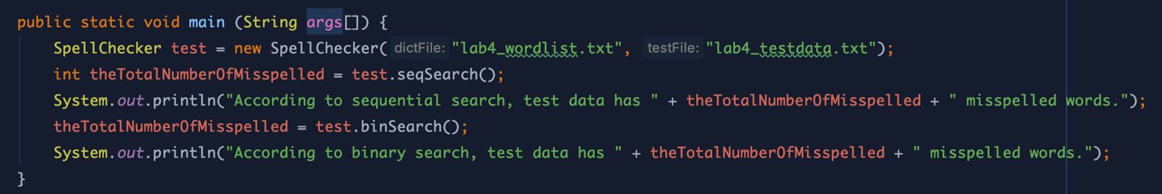

1. Create SpellCheck object with two string parameters: world list file name as the spell checker dictionary, and test data file that needed to be spell checked.

2. Invoke seqSearch method that searches the dictionary for every word in the test data using Sequential Search. And assign the total number of misspelled words, which were not able to be found from dictionary array, to an integer variable.

3. Print the number of misspelled words gotten by sequential search.

4. Invoke binSearch method that searches the dictionary for every word in the test data using Binary Search. And assign the total number of misspelled words to the same variable with above.

5. Print the number of misspelled words gotten by binary search.

**Output :**

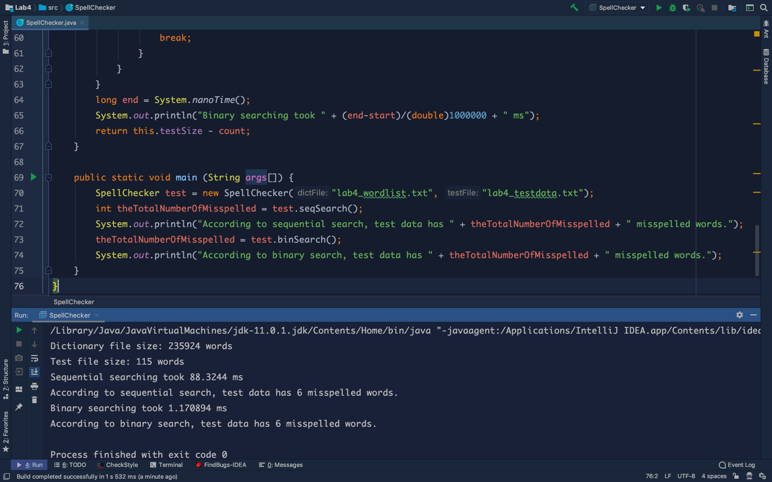

**Discussion:**

1) Sequence search

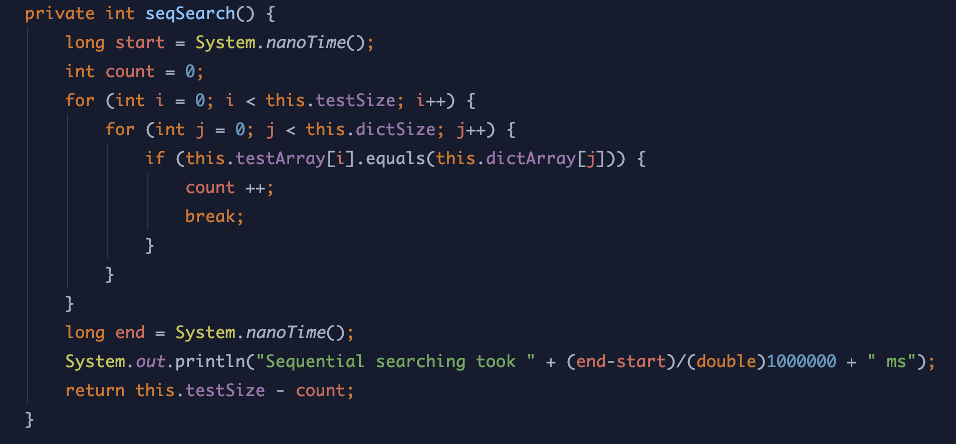

The basic operation is a comparison in the innermost loop on 6th line. Assume that the size of test array is n and the size of dictionary array is k. So, the basic operation will be occurred $\sum_{i=0}^{n}{\sum_{j=0}^{k}{1}}$ times.

Therefore, the worst time complexity will be:

$$T(n) = \sum_{i=0}^{n}{\sum_{j=0}^{k}{1 = \sum_{i=0}^{n}{(k+1) = (n+1)k + (n+1) = (k+1)n + k + 1}}}$$

Finally, the big-O efficiency class of sequential search is O(n).

2) binary search

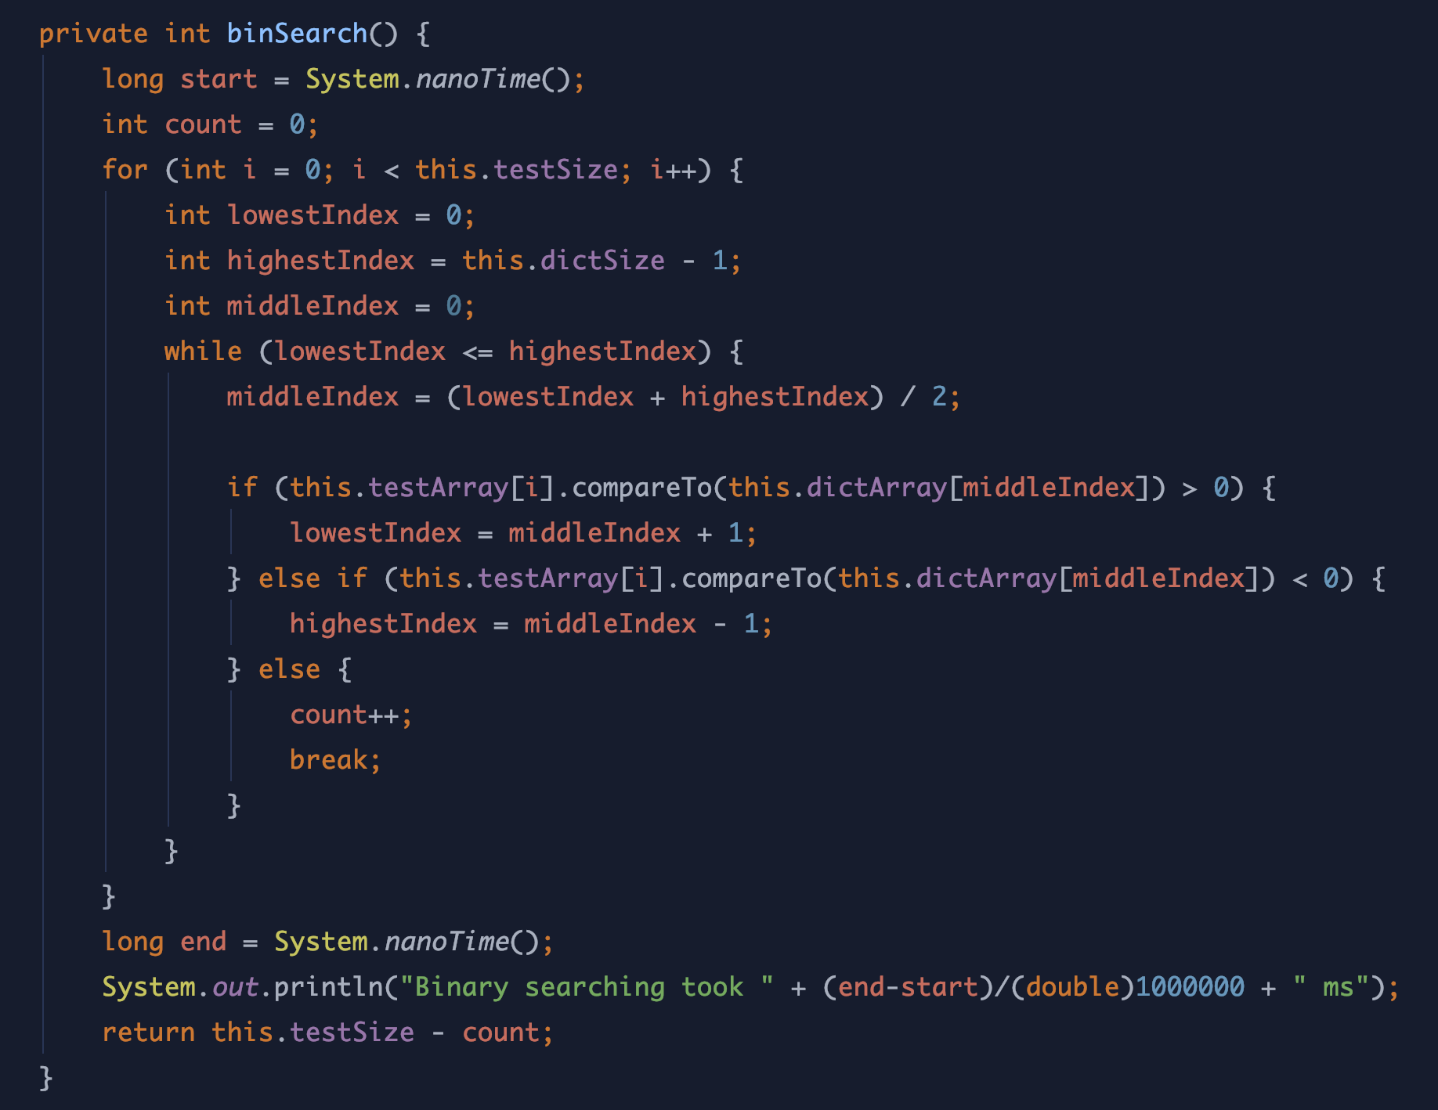

The basic operation is a comparison in the innermost loop on 11th line. Assume that the size of test array is n and the size of dictionary array is k. So, the basic operation will be occurred times.

Therefore, the worst time complexity will be: